**Assignment -1**

1. **Alarm should sound in one manner if temp is above 60c.**
2. **Alarm should sound with another frequency if motion is detected in PIR sensor.**

**Included following sensor: Arduino, PIR sensor, TMP sensor, piezo alarm.**

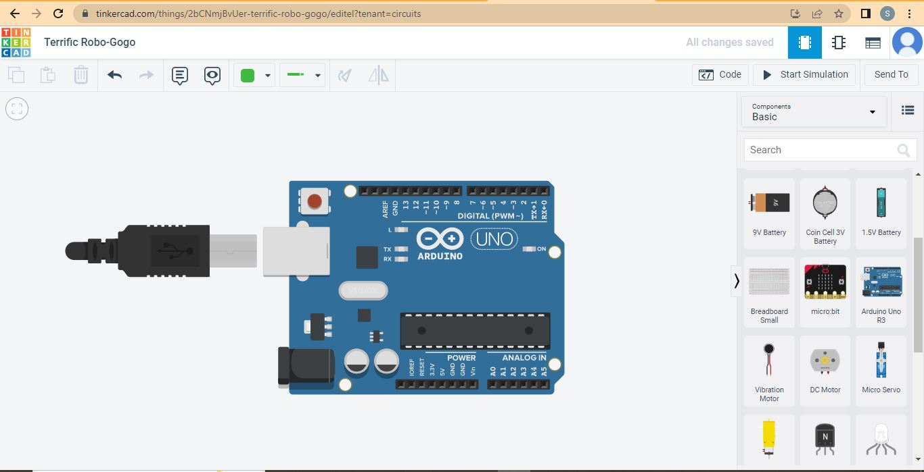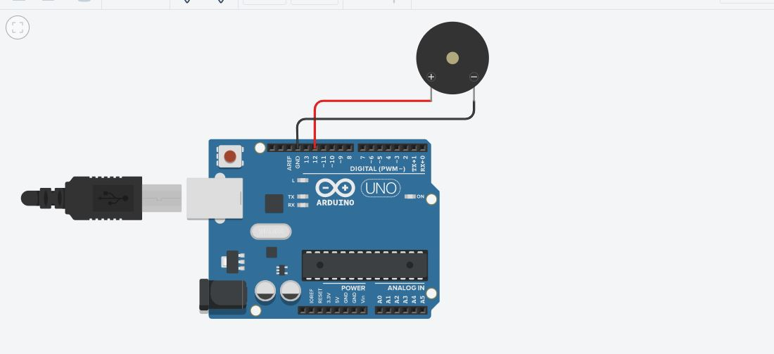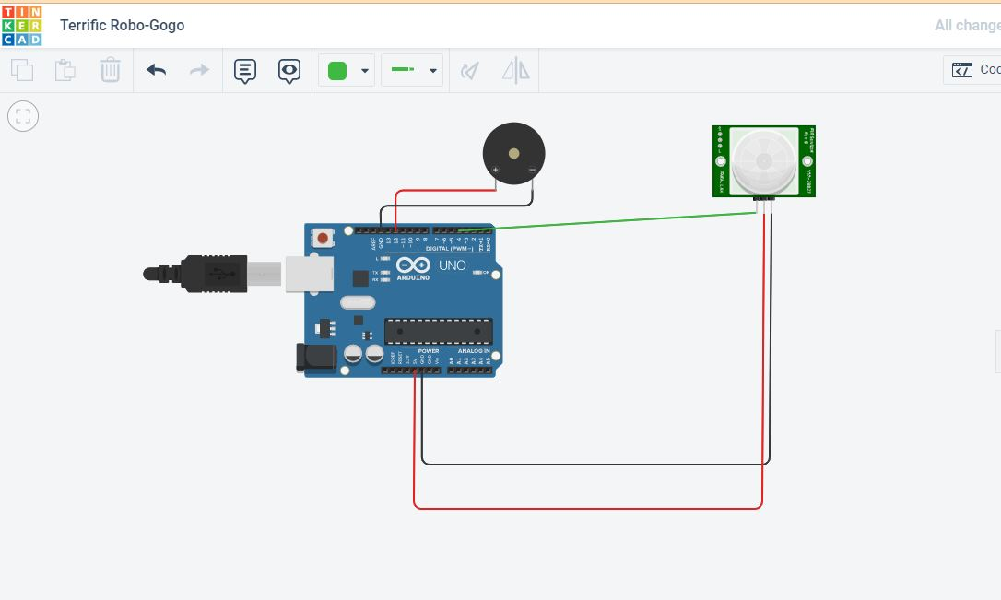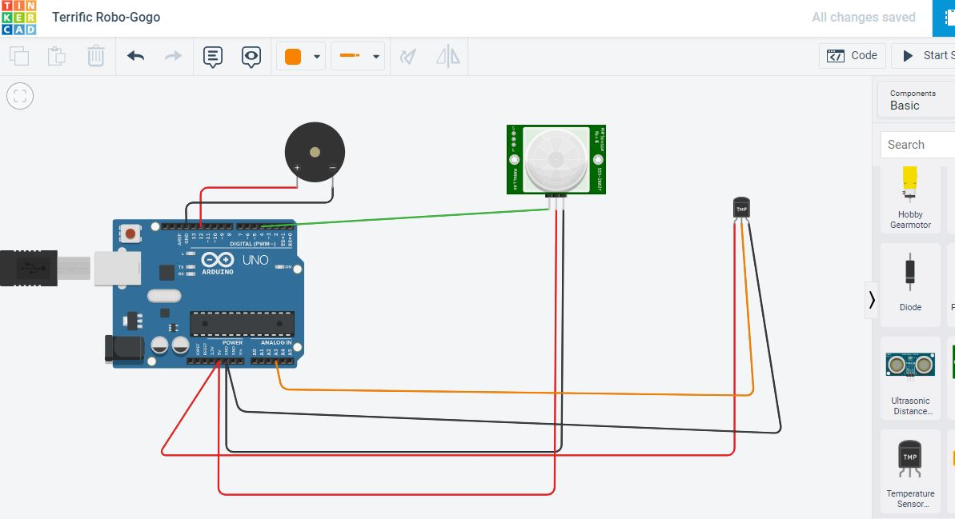

**CODE:**

float temp;

void setup()

{

pinMode(4,INPUT);

pinMode(12,OUTPUT);

Serial.begin(9600);

}

void loop()

{

if(digitalRead(4)==HIGH)

{

tone(12,523,1000);

} else {

noTone(12);

}

temp=analogRead(A3);

Serial.println("temp:");

Serial.println(temp);

temp=temp*0.48828125;

Serial.println(temp);

if(temp>=110.84){

tone(12,100,2000);

Serial.println("Above 6o c temperture");

}

else{

noTone(12);

}

}

**Output:**

**PIR Sensor alarm**

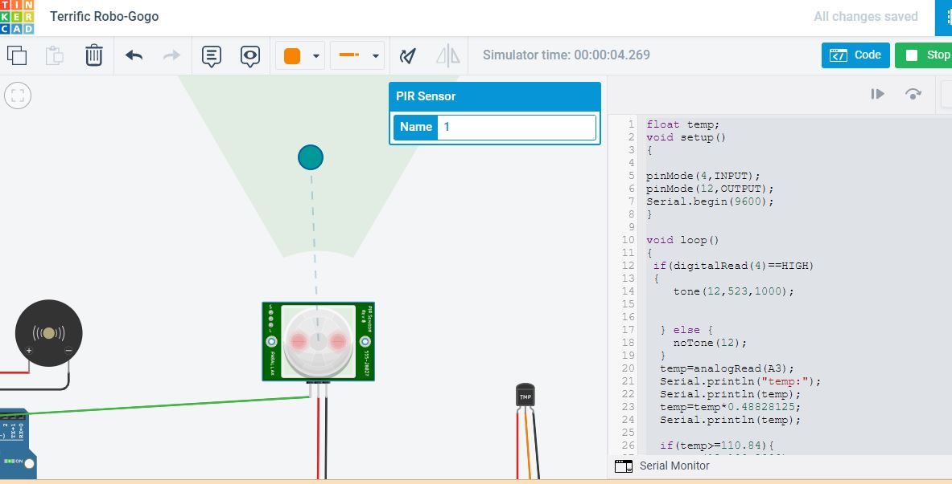

**Low Temperature:**

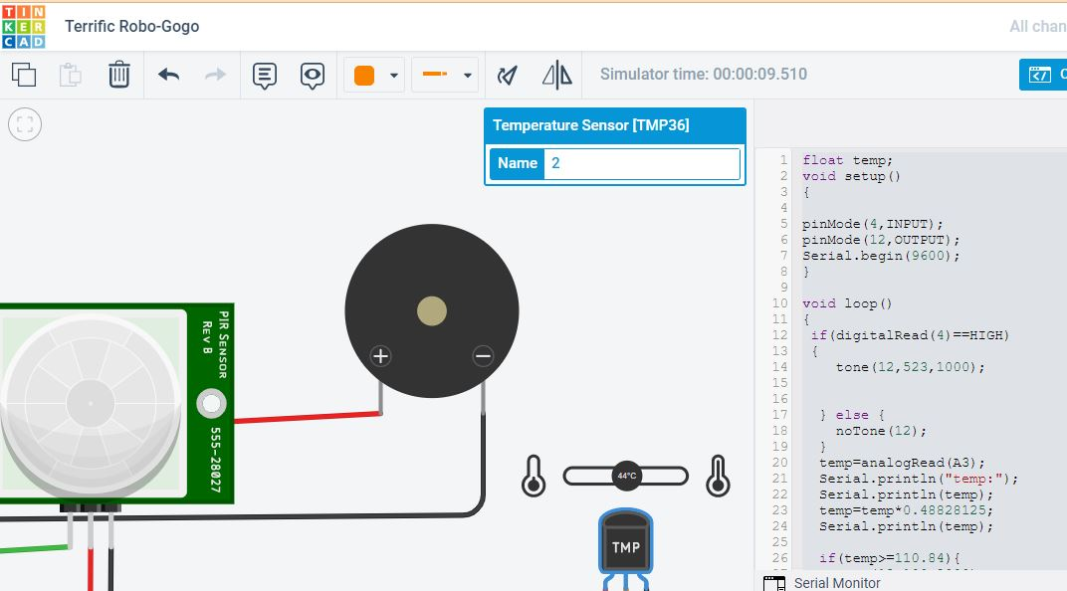

**High Temperature:**

